Happiness LABS
[A creative and memorable workshop experience for individuals living with dementia and their care partners]

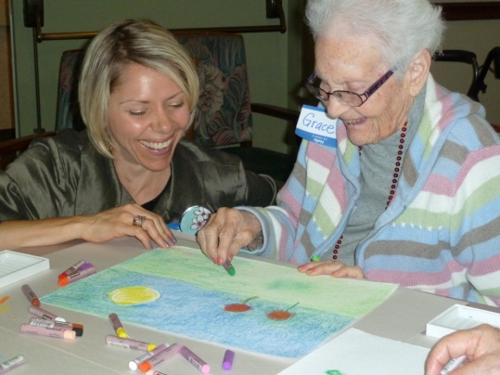

PARTICIPATE IN THE CREATIVE EXPERIENCE.
Need something to smile about? Happiness Labs apply the art and science of joy in a creative workshop experience to enrich the lives of individuals with Alzheimer’s and other forms of dementia. Each engaging 1-1/2-hour session encourages 10-15 participants and their care partners to share and visually interpret happiness. Along with the tangible benefits -- plenty of smiles and a memorable piece of art -- the Lab experience accentuates a growing body of research on creativity within the uninhibited mind, and the transcendent desire to be happy and its connection to better health.

SPONSOR A HAPPINESS LAB.
Happiness Lab sponsors and host sites are aging services providers, assisted living communities, memory care centers, hospitals and healthcare systems, senior centers, and Alzheimer’s and care partner support group, among others. Sponsors particularly appreciate the innovative concept’s dual purpose -- to enrich the lives of participants, and to provide marketing and publicity opportunities. Professional support available to sponsors includes public relations, photography, and art display services.
_____________________________________________________________________________________________

CONTACT LAB DIRECTORS FOR DETAILS AND SCHEDULING.

Tiffany Paige
Artisan Mind
tiffany.paige@artisanmind.org

Stuart Greenbaum
Greenbaum Public Relations
stuart@greenbaum-pr.com
_____________________________________________________________________________________________

LEARN HOW HAPPINESS IS TRENDING.

- LeadingAge Conference (October 2013): “Happiness Lab: Join us for a uniquely joyful experience”
- TIME Magazine (7-8-13): “The Pursuit of Happiness”
- Psychology Today (August 2013): “What Happy People Do Differently”
- The Atlantic (2013/01): “Creative Aging: The Emergence of Artistic Talents”
- TIME Magazine (1-9-09): “The New Science of Happiness”
- Gold River Messenger (July 2013): “Eskaton Project: The Art of Joy”

