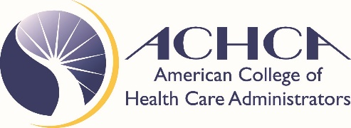
Position Statement

Strict Liability for Nursing Home Administrators

The American College of Health Care Administrators (ACHCA) is an advocate of excellence in long-term care and post-acute care, and our organization works to develop and educate Administrators of nursing homes to ensure quality outcomes for residents and patients.

ACHCA supports a system of holding nursing homes accountable and responsible for the safety and quality of life of those in their charge and care.

However, ACHCA does not now, nor will it ever, support the concept of strict liability for the individual nursing home administrator.

Strict liability calls for the punishment of individuals who are not trained in health care. Strict liability holds the Administrator criminally, professionally and personally liable for the actions or inactions of other people. These are business people managing health care providers in a high-pressure situation. Administrators must deal with regulations, legislation, compliance issues, staff, residents, patients, and families, in addition to reporting to their owner or board of directors.

Currently, each of the 50 states in our country has rules and regulations governing management and practices of nursing homes, in addition to the federal regulations that provide oversight and guidance to nursing homes.

It is our position that the Administrator is well-regulated and held accountable for the performance of their duties. We do not believe any additional liability should be imposed on these professionals.

The federal regulations governing nursing homes do not call for strict liability for nursing home administrators so we do not see a legal precedent for strict liability at the state level.

Nursing home administrators are motivated by a desire to serve and to help those in need. They are a special kind of person in that they have compassion and selflessness in the service of others. While they are a different kind of business person, they are in the end, business people.

As “the CEO of the building,” the Administrator is responsible for the daily management of the facility and all its departments. They are not the individual providing direct care or medical services to the residents and patients in their care.

The training of the Administrator is not clinical. They do not dispense medications; they do not tend to the sick; they do not change bandages. The Administrator makes sure that qualified staff is hired to provide these services. Holding the Administrator personally and individually liable for the actions of others in a field that they do not practice is unacceptable.

No other similar professional is held to this standard and to this level of personal liability.

Strict liability places additional stress on individuals that we need to perform at their best every day.

ACHCA believes that strict liability will create a crisis in the delivery of long-term care, as those with the passion and experience to fulfill this important role will leave the profession. It creates a barrier to new professionals entering the profession. No one should fear losing their home, their license or their freedom because of someone else’s mistake at work.

ACHCA’s position is that Nursing Home Administrators should be supported, not punished.

Policy adopted by Committee June 8, 2017
ACHCA Board approval on July 13, 2017.

